# Alex Grimes CS 340 README

## About the Project/Project Title

This project is the CRUD (Create, Read, Update, and Delete) module for interacting with mongodb. It allows for modification to the mongodb,

## Motivation

This project is being created to interact with mongodb. Mongodb provides horizontal sharding, allowing for sub documents within a document. MongoDb is a great alternative to SQL for these reasons.

## Getting Started

After creating the python module, importing MongoClient and ObjectId are essential. The __init__ method must be created to initialize the MongoDB. This will require username pass and the auth source.

## Installation

*Requires installation of:*

*Python*

*MongoDB*

*Jupyter Notebook*

## Usage

*Use this space to show useful examples of how your project works and how it can be used. Be sure to include examples of your code, tests, and screenshots.*

### Code Example

def create(self, data):

if data is not None:

# Will return the generated _id object

animal_id = self.database.animals.insert(data) # data should be dictionary

# Insert successful (_id generated so document inserted)

if animal_id is not None:

return True

else:

return False

else:

raise Exception('Nothing to save because data parameter is empty')

# Function to Query documents ~ R in CRUD

def read(self, query_data):

if query_data is not None:

result = self.database.animals.find(query_data, {'_id': False})

else:

result = self.database.animals.find({}, {'_id': False})

# Returns a cursor object

return result

def update(self, query_data, new_data):

if query_data is not None and new_data is not None:

# Count the number of documents with the original information

count_to_update = self.database.animals.count_documents(query_data)

# Count the number of documents that currently match the new information

count_new_data = self.database.animals.count_documents(new_data)

# Evaluate if there are any documents to update

if count_to_update != 0:

# Count the number of documents that currently match the new information

count_current_match = self.database.animals.count_documents(new_data)

updated_animal = self.database.animals.update_many(query_data, {'$set': new_data})

# Count the number of documents with the new information again

count_new_data = self.database.animals.count_documents(new_data)

# Calculate how may documents were updated

count_updated = count_new_data - count_current_match

# Verify the number of documents updated = the number to update

if count_updated == count_to_update:

return updated_animal.raw_result

else:

print('There was a problem! - ', count_to_update, ' should have been updated but actual count was ', count_new_data)

else:

print('Nothing to update because no documents match data parameter')

else:

raise Exception('Nothing to update because one or more data parameters are empty')

# Function to Delete documents ~ D in CRUD

def delete(self, delete_data):

if delete_data is not None:

# Count the number of docments to delete

count_to_delete = self.database.animals.count_documents(delete_data)

if count_to_delete != 0:

# Count the total number of documents

count_original = self.database.animals.count_documents({})

result = self.database.animals.delete_many(delete_data)

# Count the number of documents again

count_new = self.database.animals.count_documents({})

# Calulate how many documents were deleted

count_deleted = count_original - count_new

# Verify the number of documents deleted = the number to delete

if count_deleted == count_to_delete:

return result.raw_result

else:

print('There was a problem! - ', count_to_delete, ' should have been removed but actual count was ', count_deleted)

else:

print('Nothing to delete because no documents match data paramater')

else:

raise Exception('Nothing to delete because data parameter is empty')

### Tests

def create(self, data):

if data is not None:

# Will return the generated _id object

animal_id = self.database.animals.insert(data) # data should be dictionary

# Insert successful (_id generated so document inserted)

if animal_id is not None:

return True

else:

return False

else:

raise Exception('Nothing to save because data parameter is empty')

# Function to Query documents ~ R in CRUD

def read(self, query_data):

if query_data is not None:

result = self.database.animals.find(query_data, {'_id': False})

else:

result = self.database.animals.find({}, {'_id': False})

# Returns a cursor object

return result

def create(self, data):

if data is not None:

# Will return the generated _id object

animal_id = self.database.animals.insert(data) # data should be dictionary

# Insert successful (_id generated so document inserted)

if animal_id is not None:

return True

else:

return False

else:

raise Exception('Nothing to save because data parameter is empty')

# Function to Query documents ~ R in CRUD

def read(self, query_data):

if query_data is not None:

result = self.database.animals.find(query_data, {'_id': False})

else:

result = self.database.animals.find({}, {'_id': False})

# Returns a cursor object

return result

def create(self, data):

if data is not None:

# Will return the generated _id object

animal_id = self.database.animals.insert(data) # data should be dictionary

# Insert successful (_id generated so document inserted)

if animal_id is not None:

return True

else:

return False

else:

raise Exception('Nothing to save because data parameter is empty')

# Function to Query documents ~ R in CRUD

def read(self, query_data):

if query_data is not None:

result = self.database.animals.find(query_data, {'_id': False})

else:

result = self.database.animals.find({}, {'_id': False})

# Returns a cursor object

return result

def create(self, data):

if data is not None:

# Will return the generated _id object

animal_id = self.database.animals.insert(data) # data should be dictionary

# Insert successful (_id generated so document inserted)

if animal_id is not None:

return True

else:

return False

else:

raise Exception('Nothing to save because data parameter is empty')

# Function to Query documents ~ R in CRUD

def read(self, query_data):

if query_data is not None:

result = self.database.animals.find(query_data, {'_id': False})

else:

result = self.database.animals.find({}, {'_id': False})

# Returns a cursor object

return result

# Test update functionality

# Query to search for information to change

data = {'breed': 'Pit Bull'}

# New information

new_data = {'breed': 'Pit Bull - Mixed'}

updated_animal = shelter.update(data, new_data)

print(updated_animal, '\n')

# Pass original data to read function- Should not return any documents

original_breed = shelter.read(data)

for animal in original_breed:

print(animal, '\n')

print('Finished displaying ', data, '\n')

# Pass new data to read function - Documents should have new information

new_breed = shelter.read(new_data).limit(3)

for animal in new_breed:

print (animal, '\n')

print('Finished displaying ', new_data, '\n')

# Test update if animal not found

original_data = {'breed': 'Loser'}

new_data = {'breed': 'Pit Bull - Horse'}

# Count the number of douments that match the original search criteria (should = 0)

count_original = shelter.count_docs(original_data)

# Call update

updated_animal = shelter.update(original_data, new_data)

# Count the number of documents with the new data - Since original was 0, this should also be 0

count_updated = shelter.count_docs(new_data)

print(updated_animal, '\n')

print('Number of documents found with query ', original_data, ': ', count_original)

print('Number of documents found with query ', new_data, ': ', count_updated, '\n')

# Test delete functionality

data = {'name': 'Chester'}

# Count the number of documents

count = shelter.count_docs({})

delete_data = shelter.delete(data)

# Count the number of documents again - Should be -1

count2 = shelter.count_docs({})

print(delete_data, '\n')

print('Original count: ', count, ', New count: ', count2, '\n')

# Pass data to read function - Should not find the record

delete_proof = shelter.read(data)

print('Start displaying ', data, '\n')

for animal in delete_proof:

print(animal, '\n')

print('Finished displaying ', data, '\n')

# Test delete functionality if animal not found

data = {'name': '******'}

data2 = {'breed': 'Pit Bull - Mixed'}

# Count the number of documents

count = shelter.count_docs({})

delete_data = shelter.delete(data)

# Count the number of documents again - Should be the same

count2 = shelter.count_docs({})

print(delete_data, '\n')

print('Original count: ', count, ', New count: ', count2, '\n')

### Screenshots

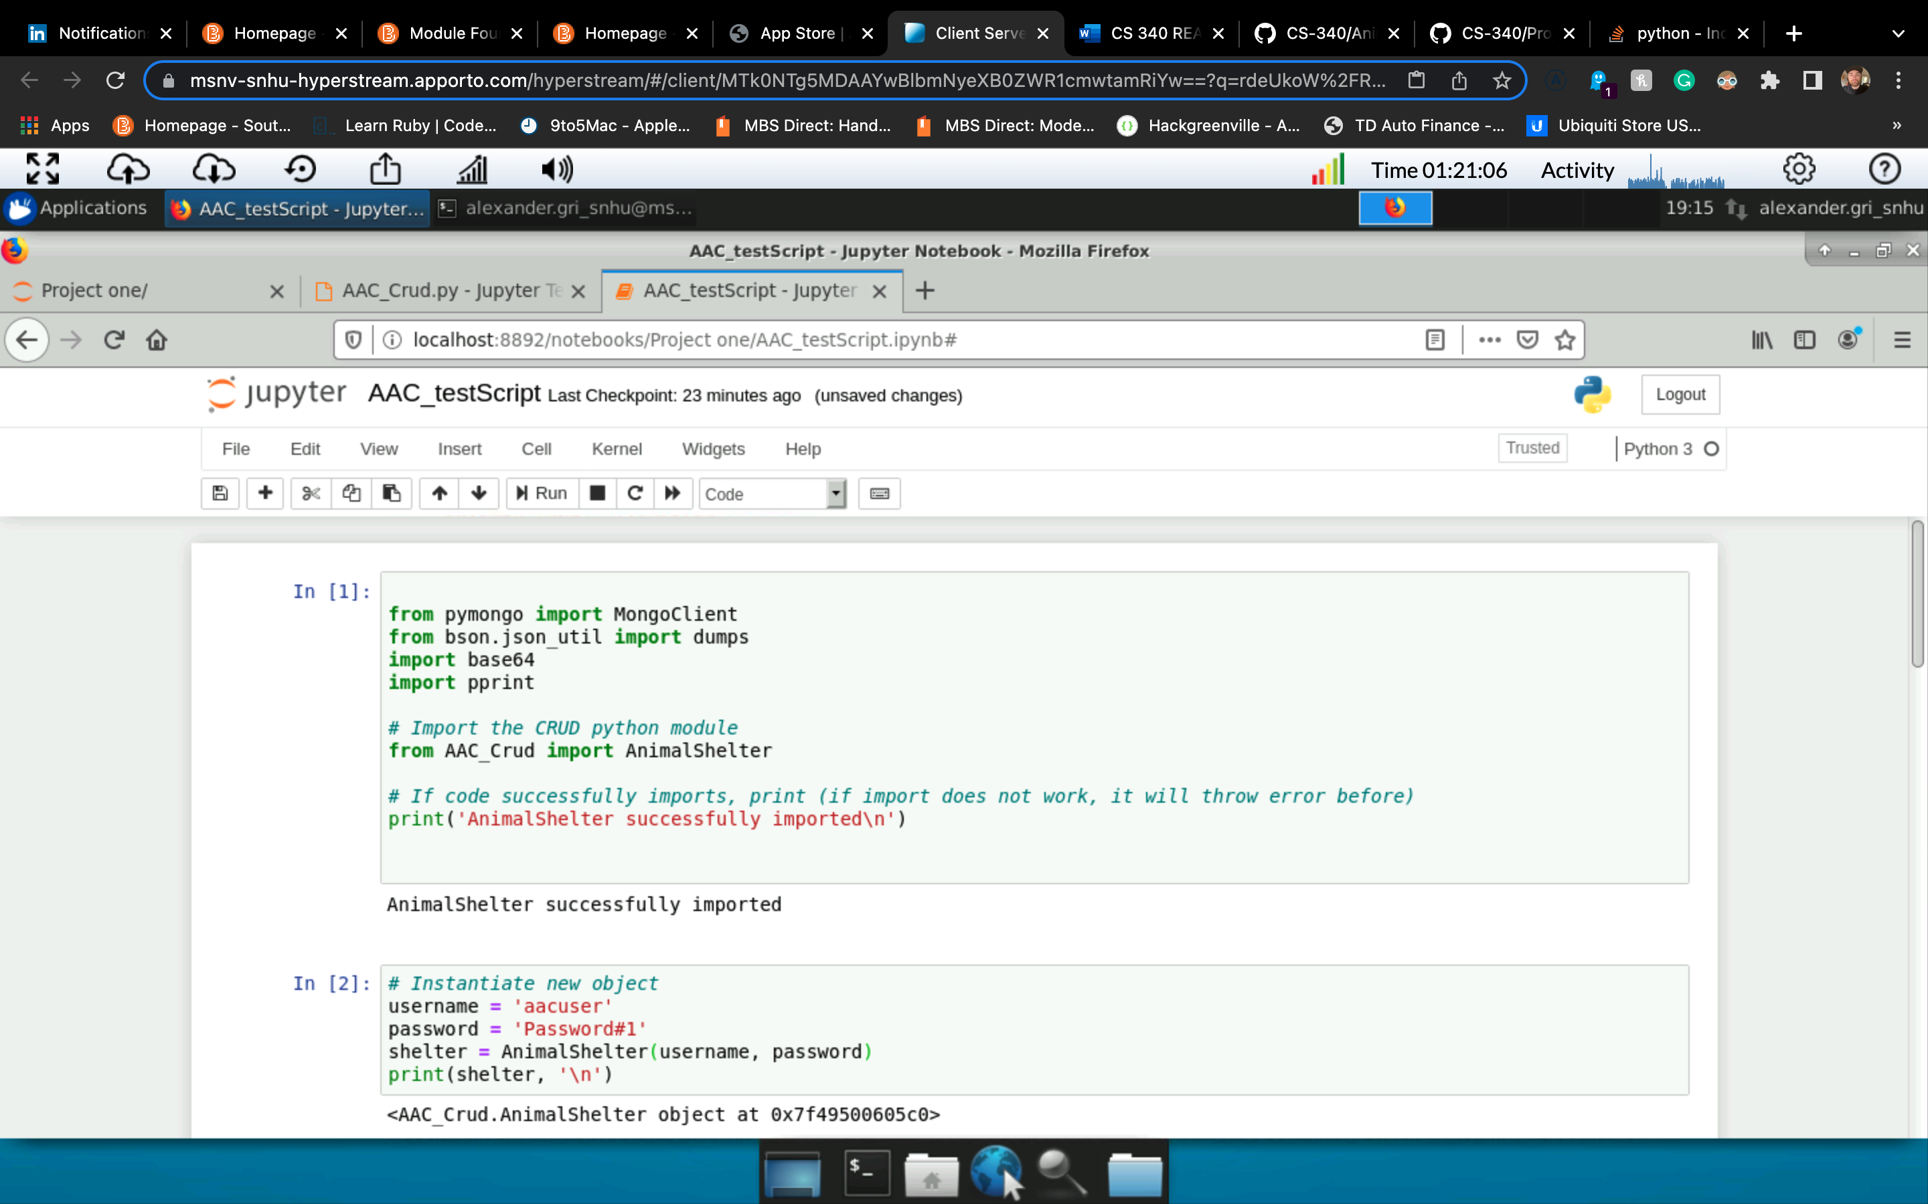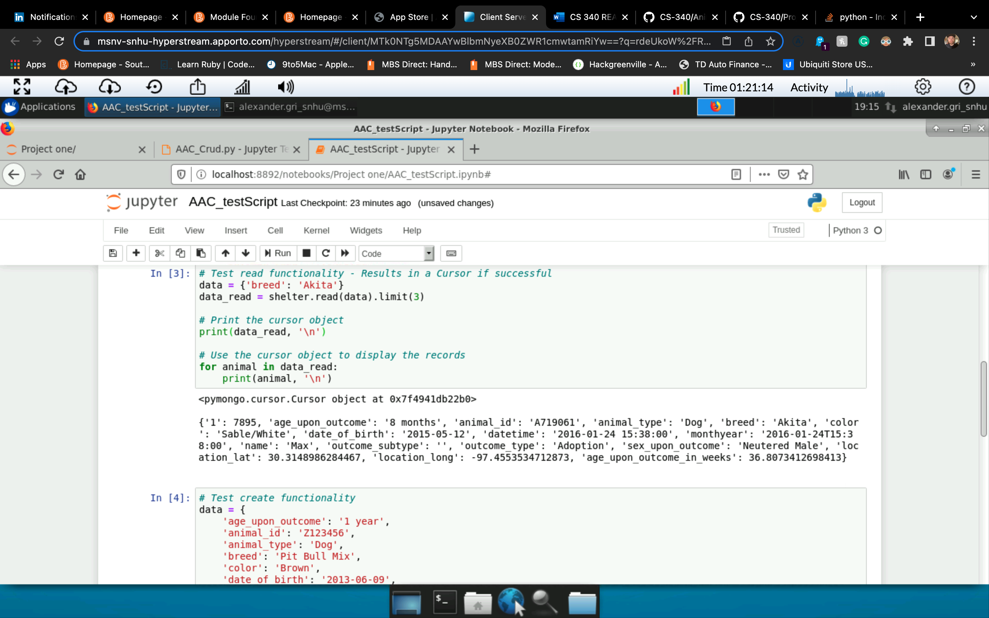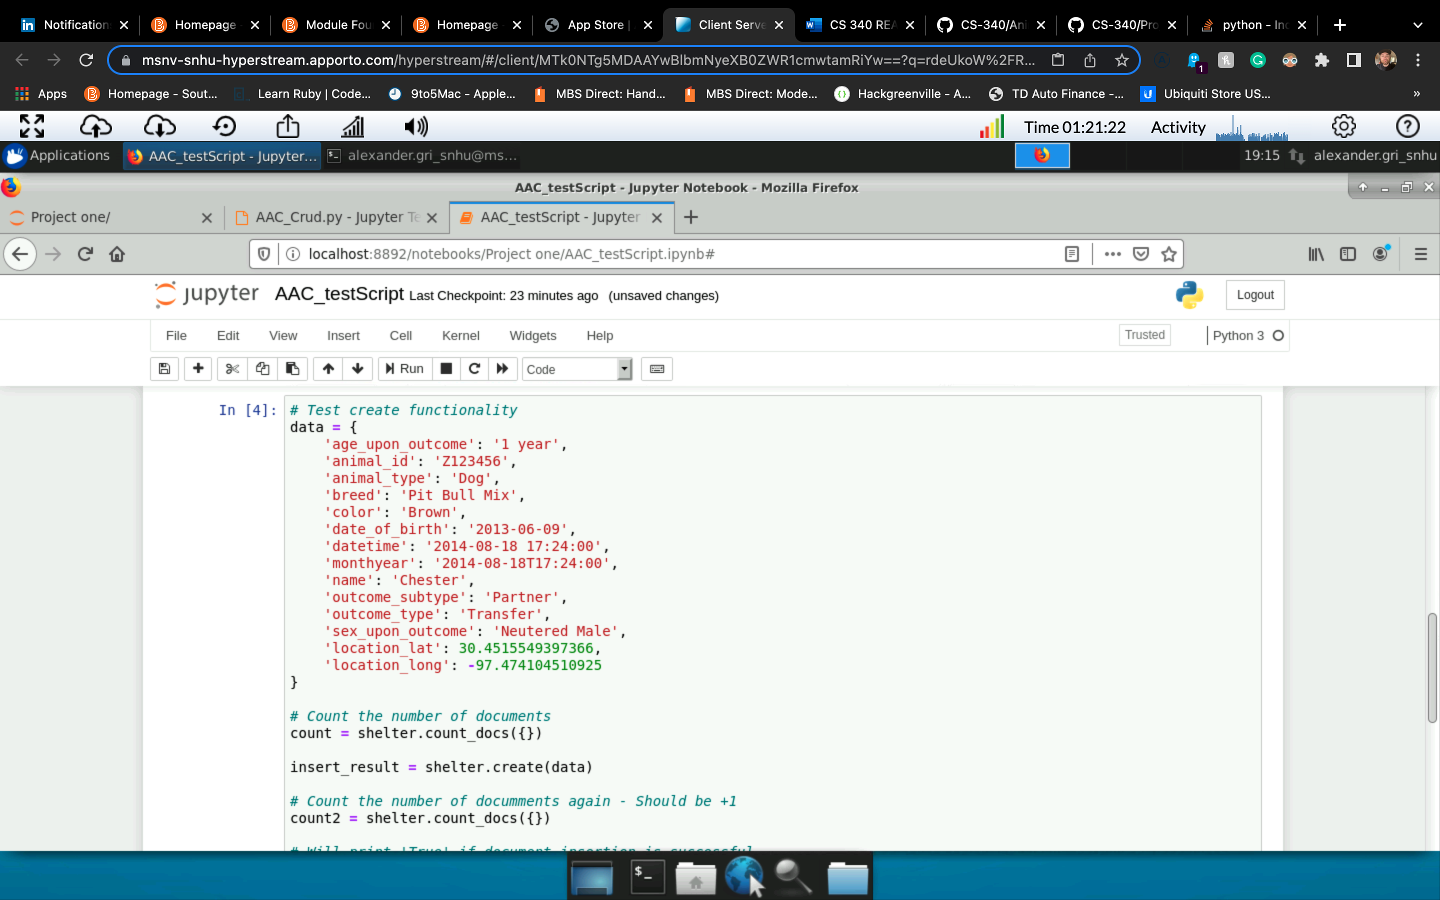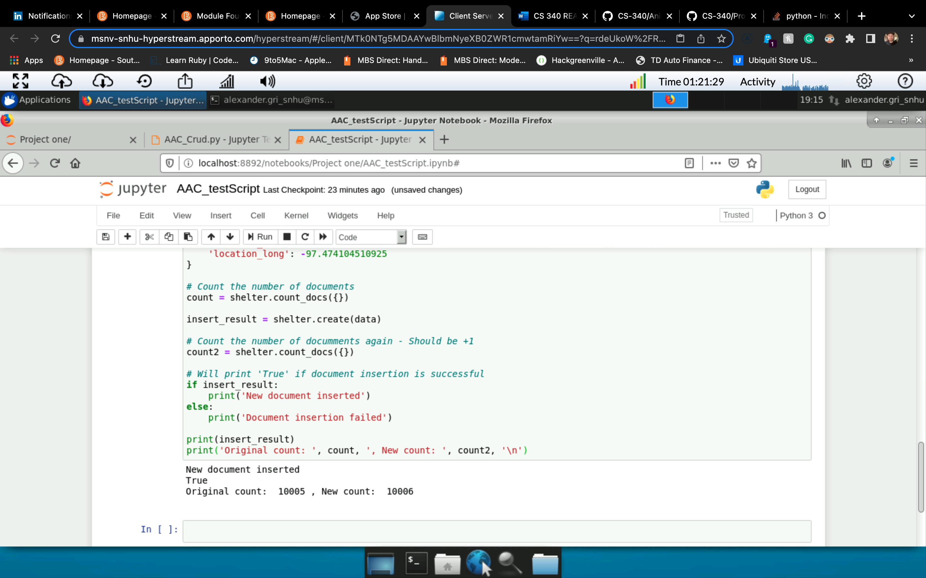

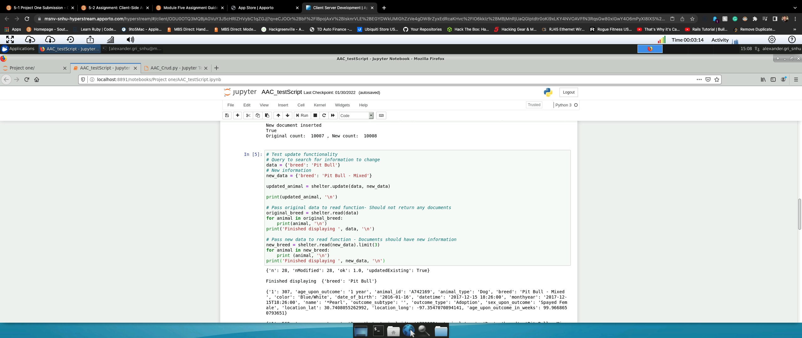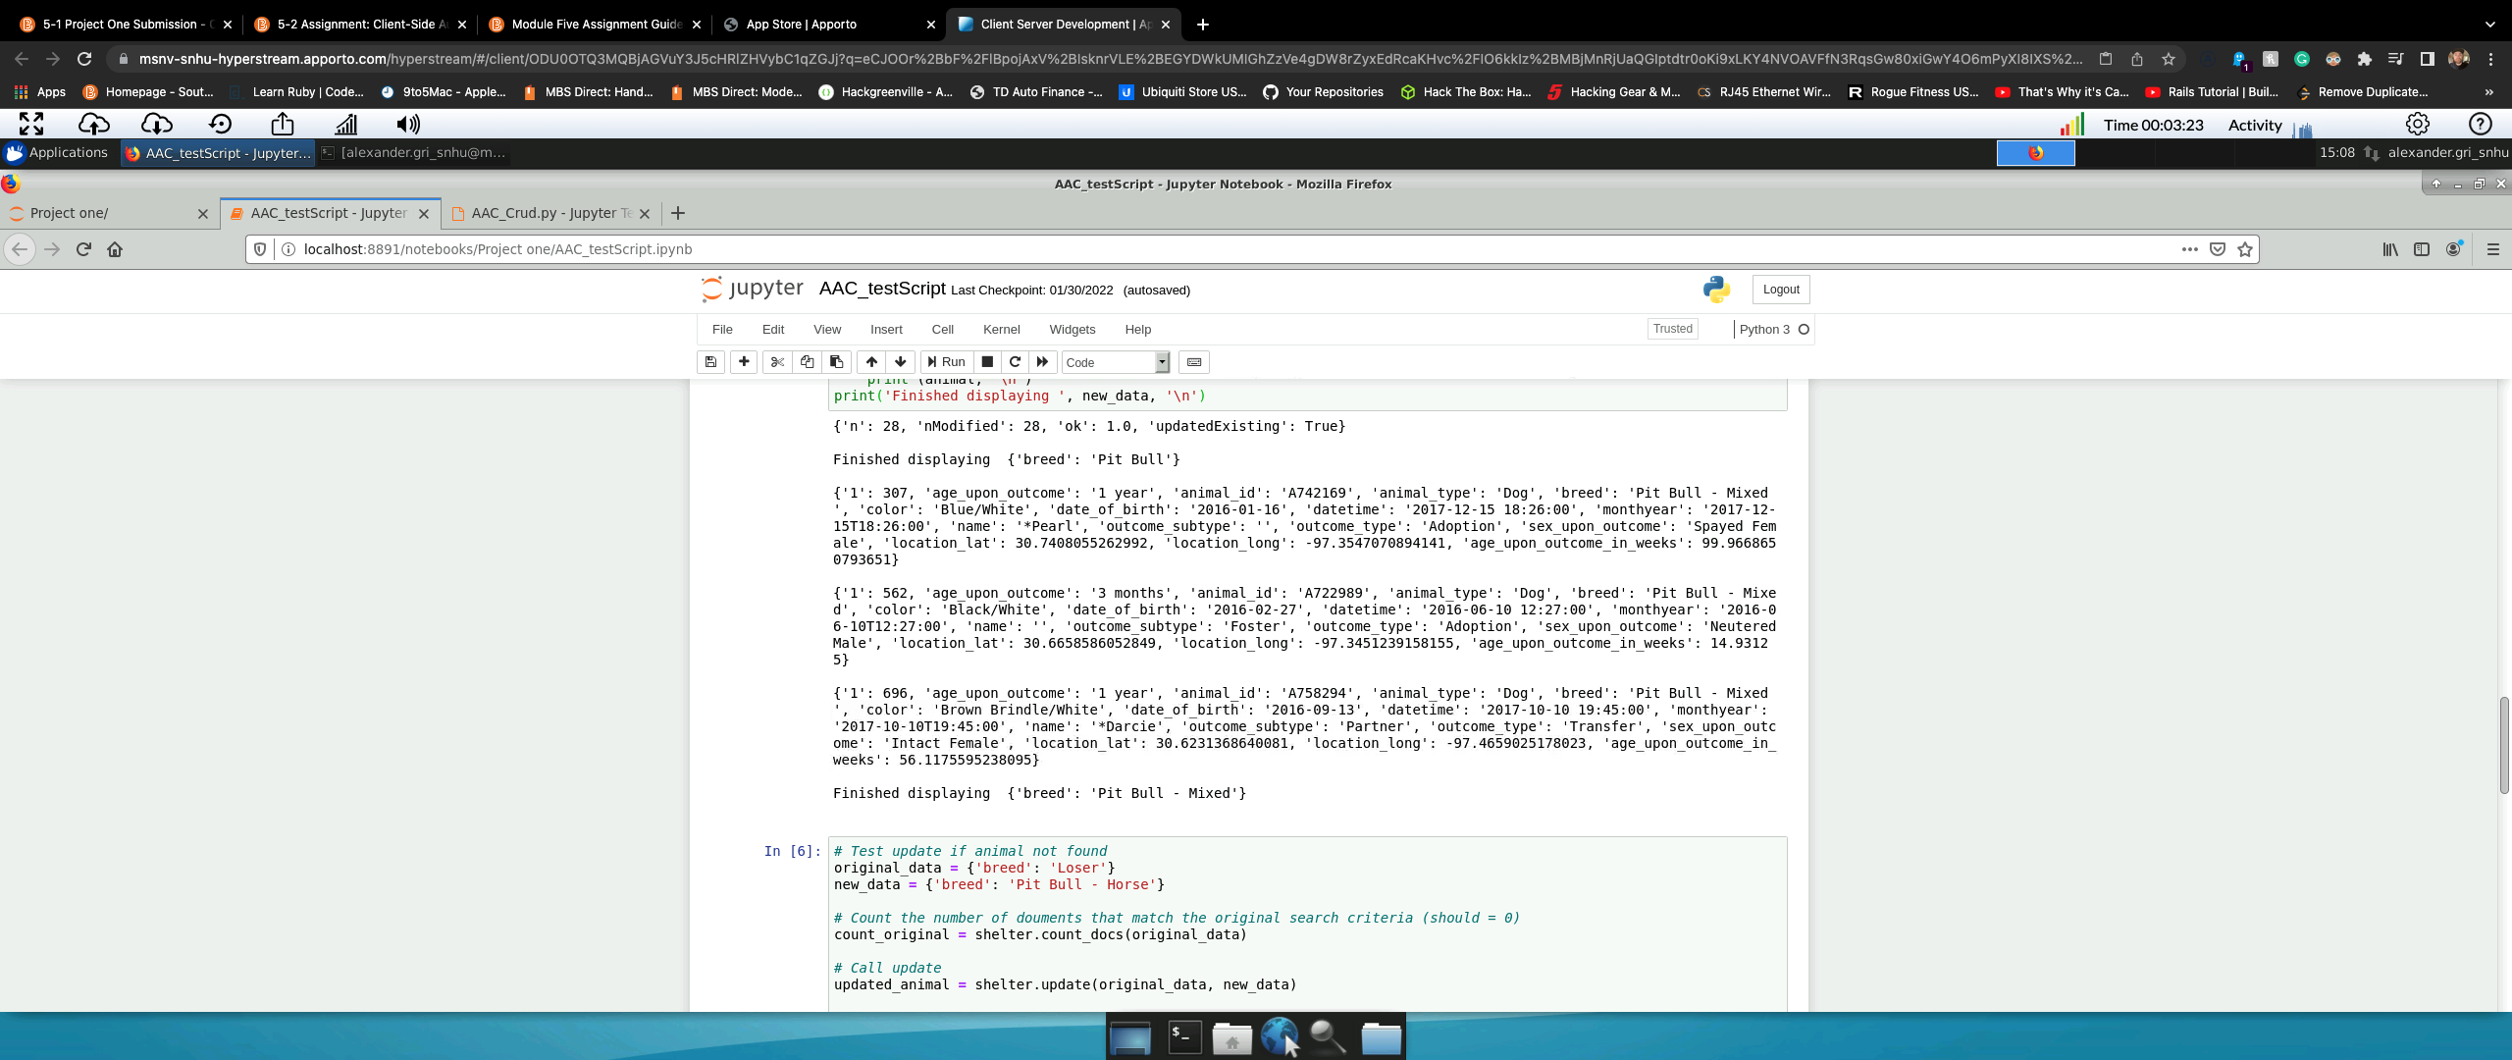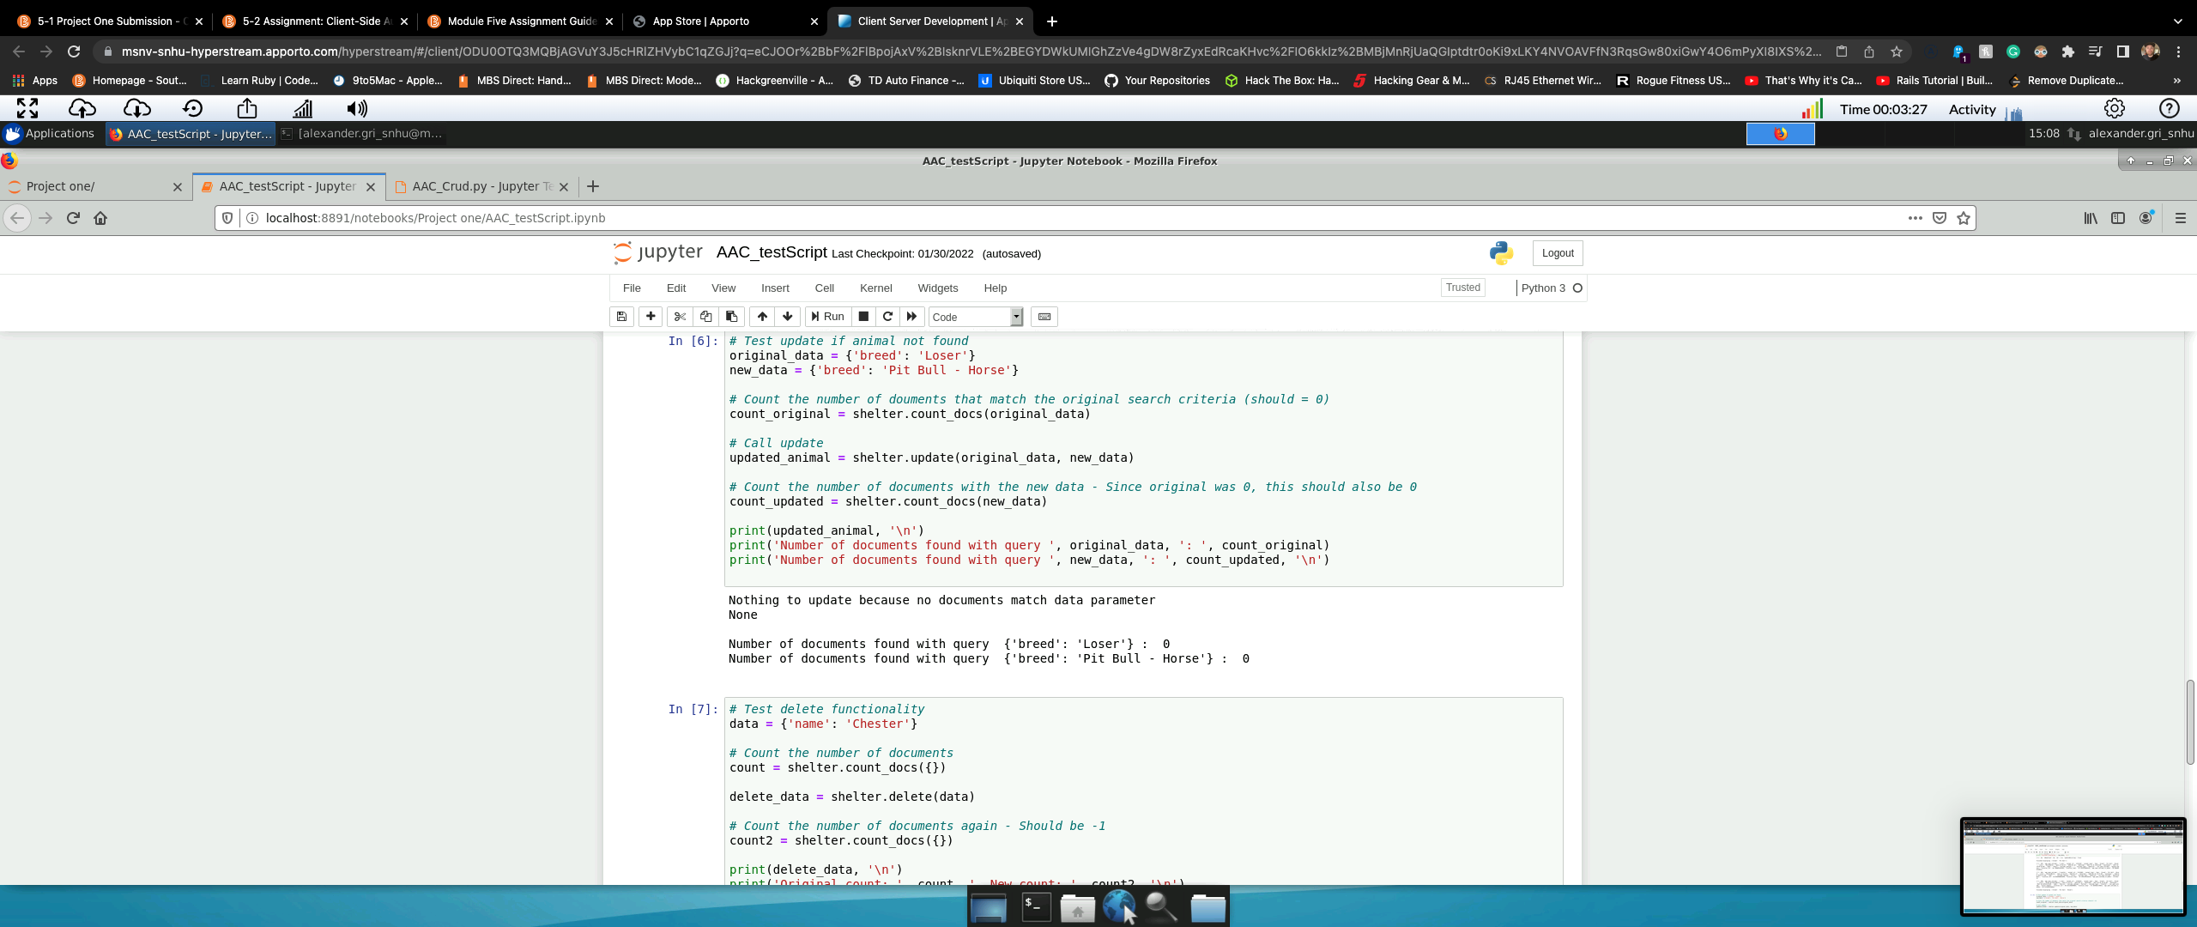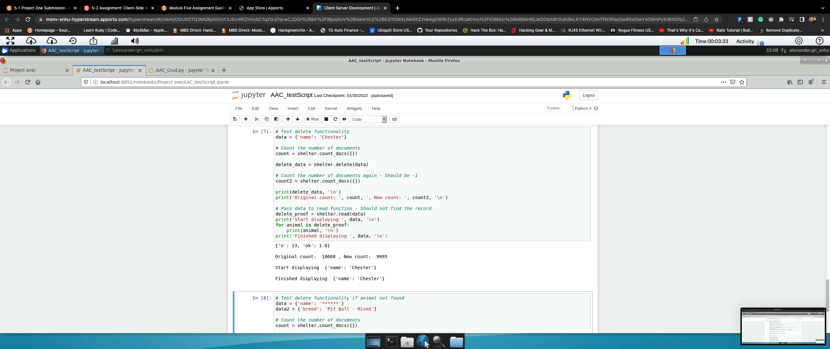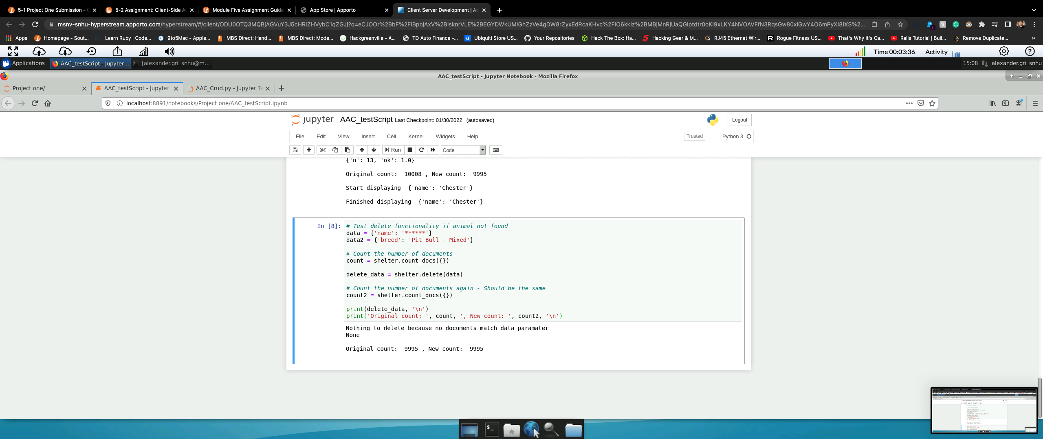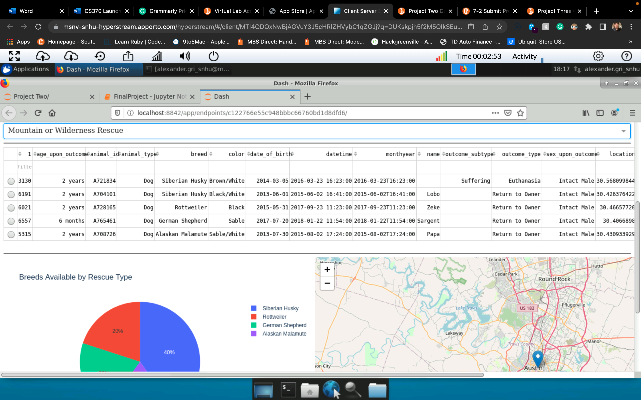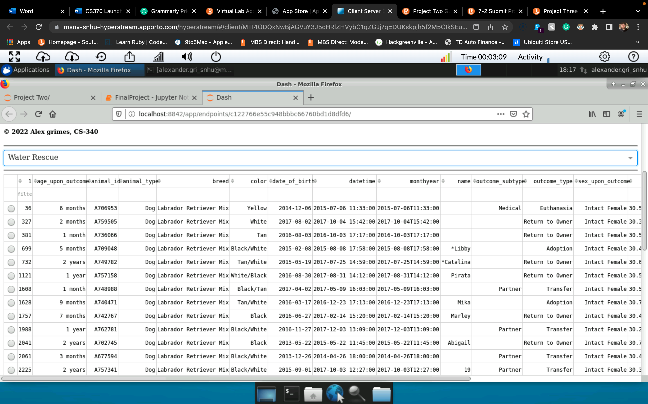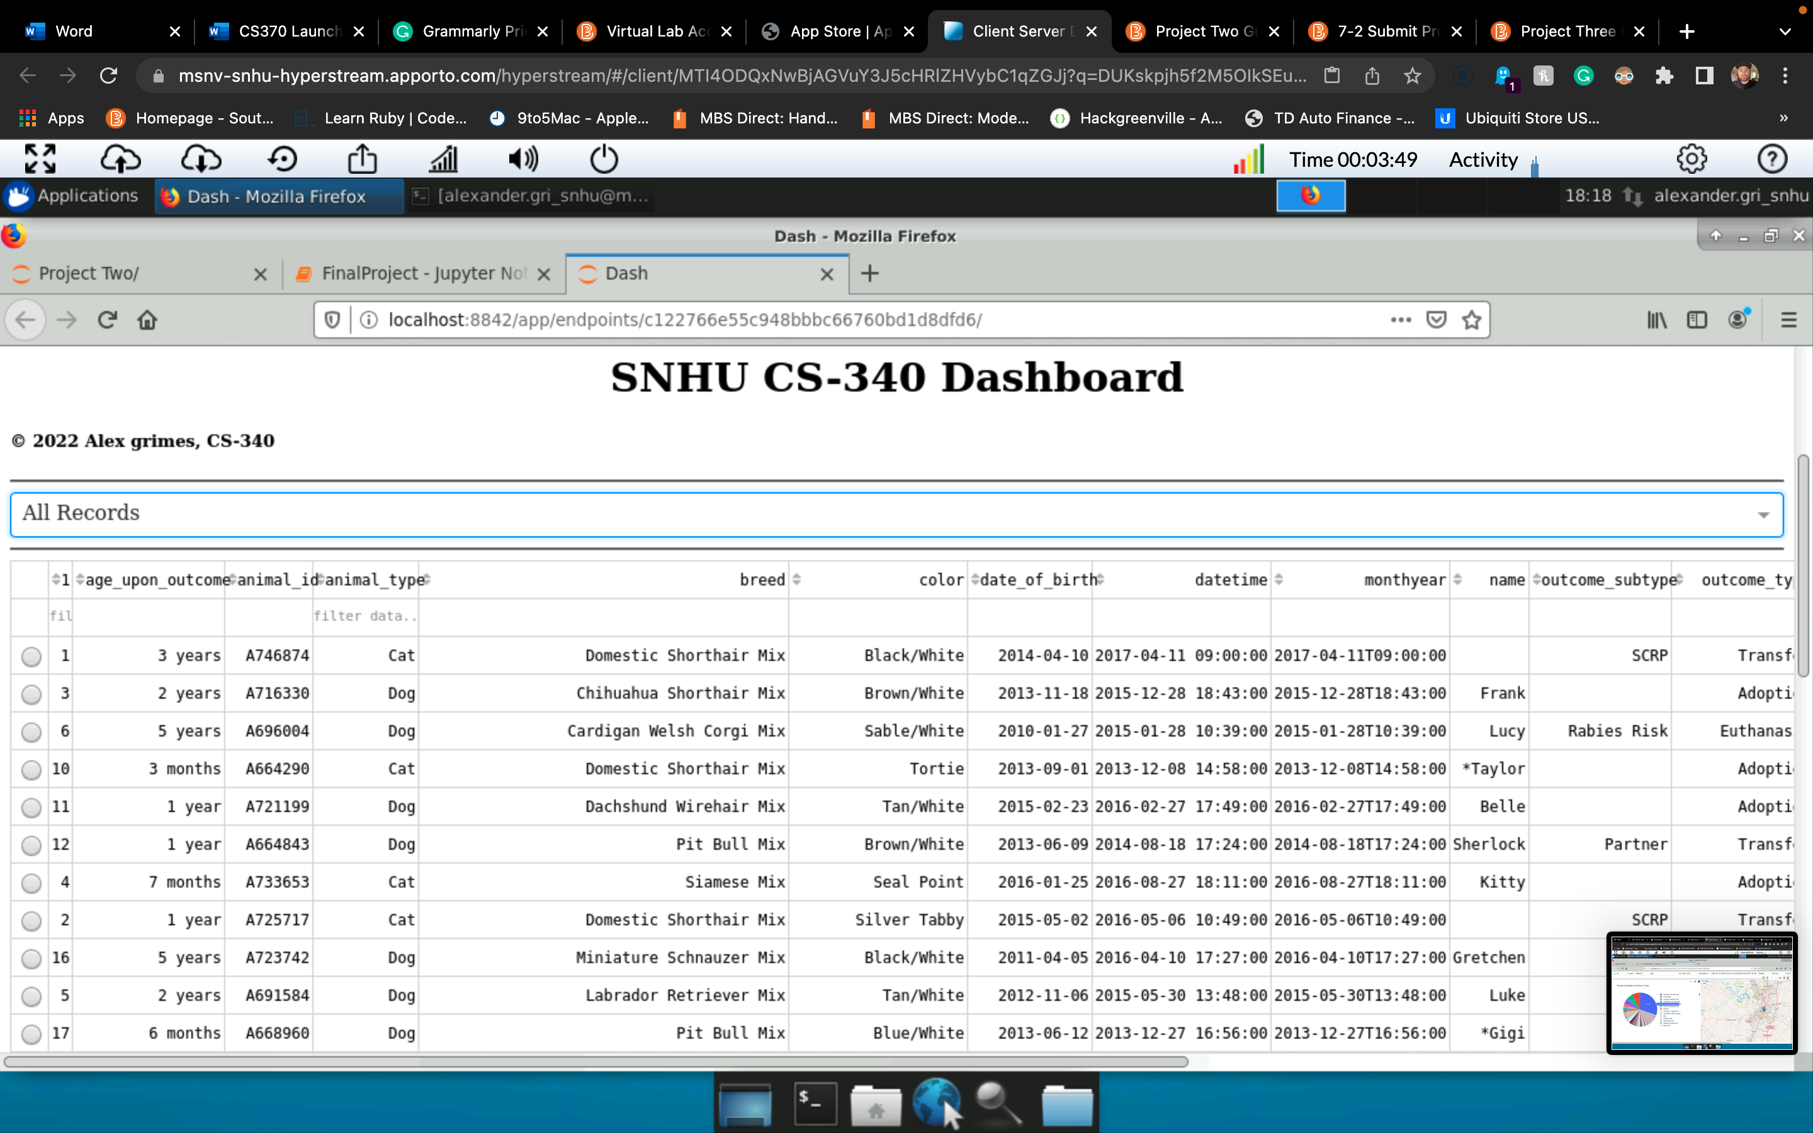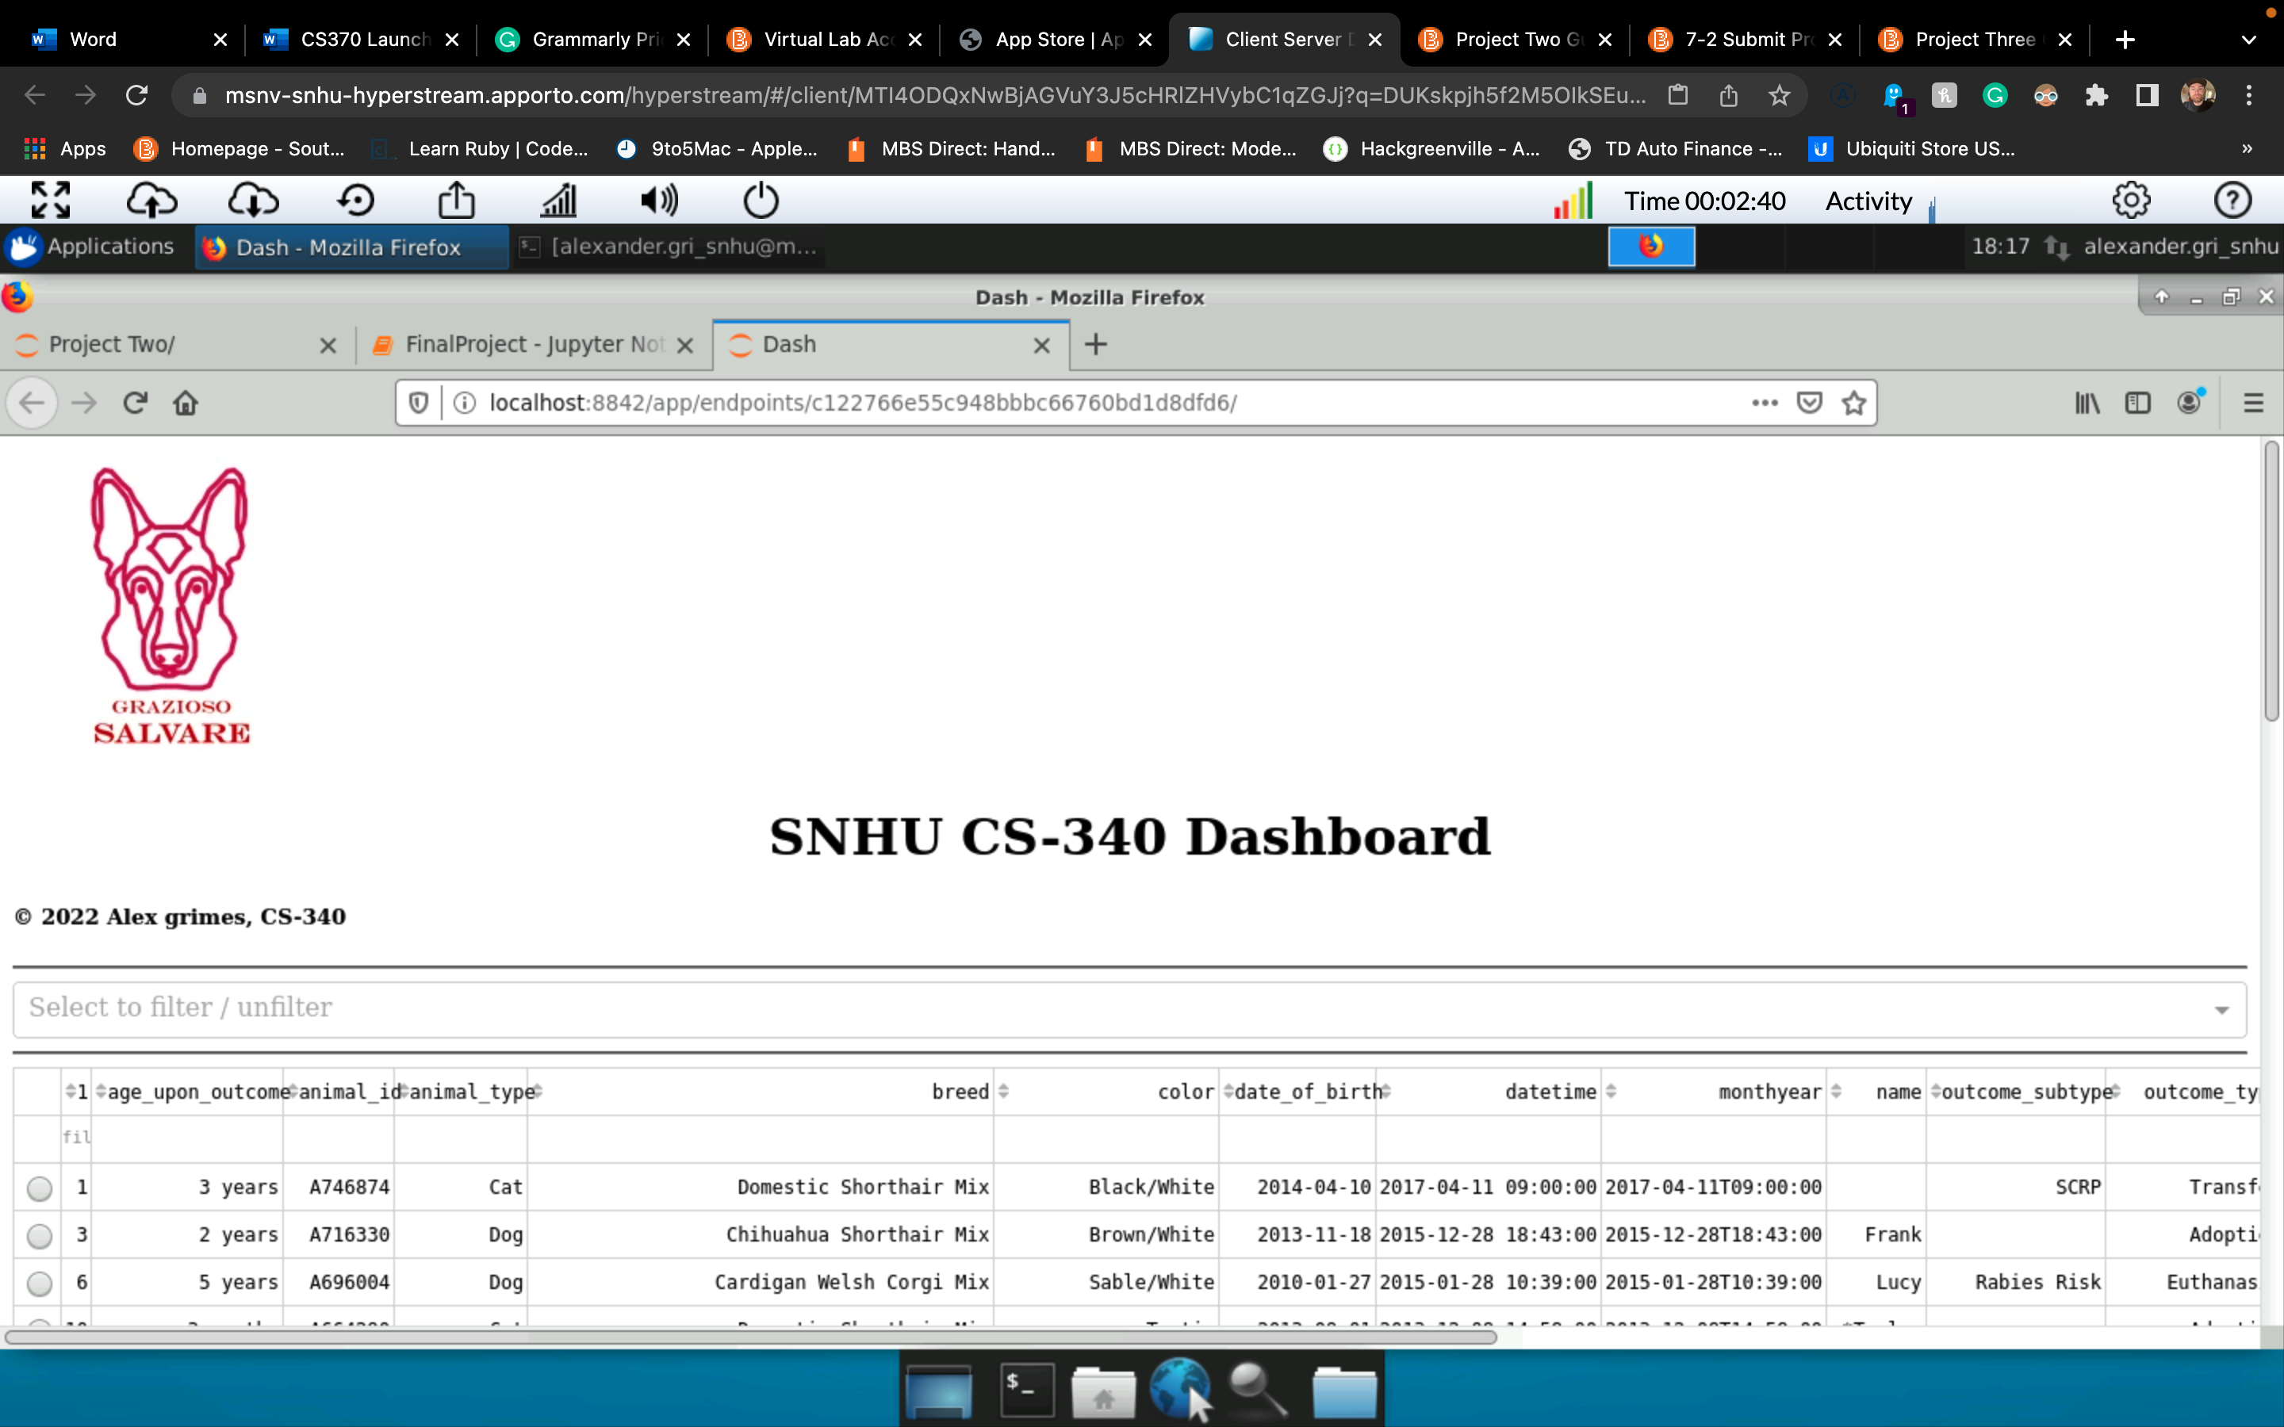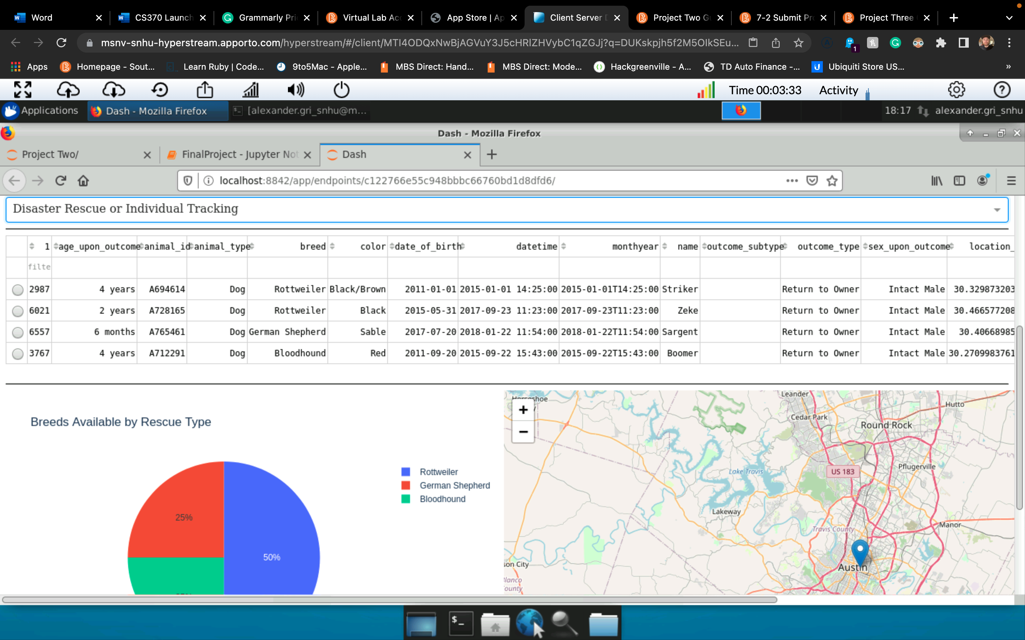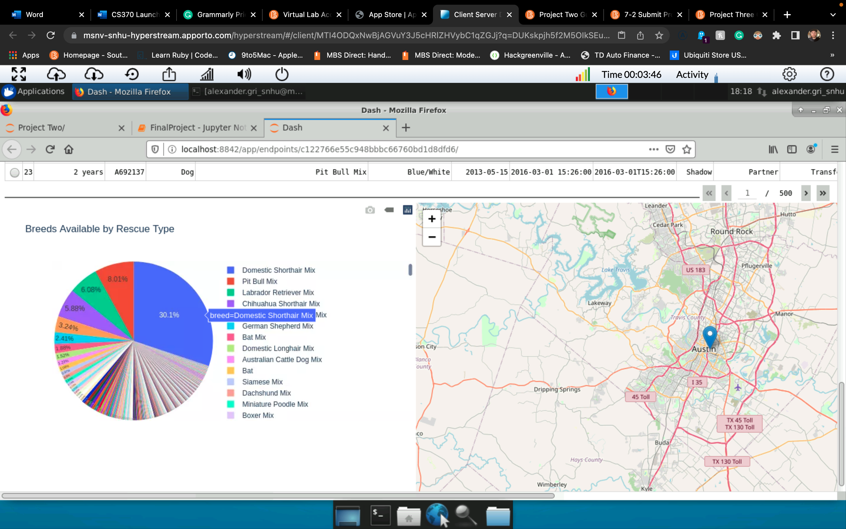

Contact

Alex Grimes